Guidelines for E&E Congress posters

The poster must be in landscape orientation.
The poster must be in English.
For your presentation you are requested to use the A0 format, ideally the provided poster template.
Avoid using trade names and keep the poster visual, clear, and concise.
Poster must be uploaded to the User zone on the Congress platform by May 15, 2024.

Guidelines on how to upload your Poster on the Congress platform
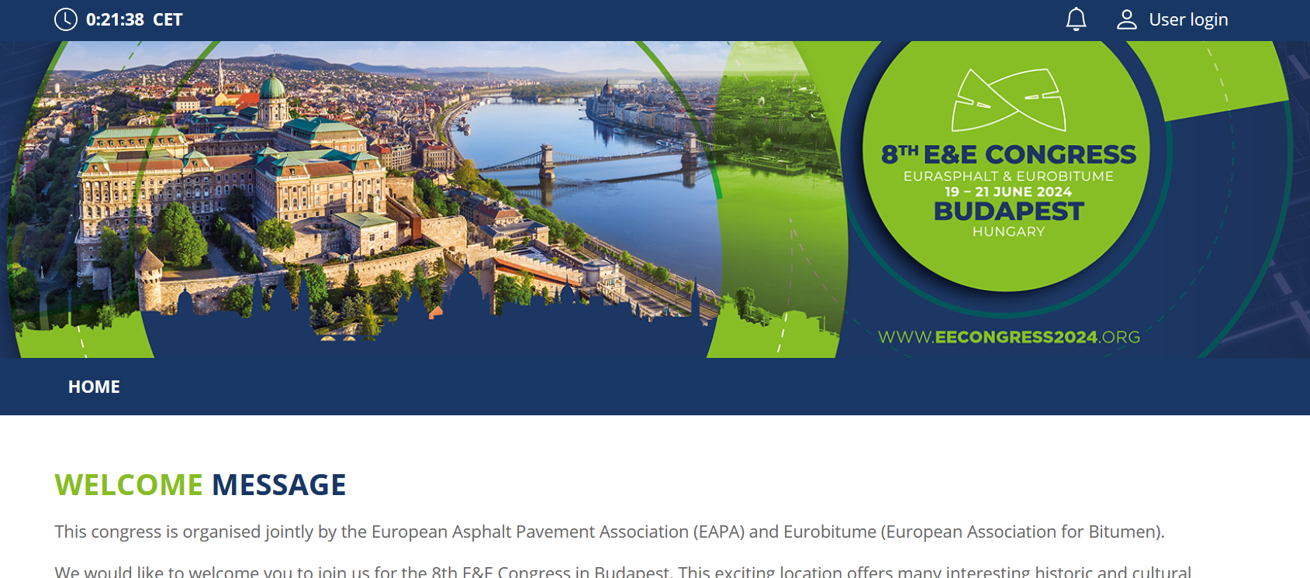
Click on the User login in the right upper corner
Please use the same email address as for the Paper submission form

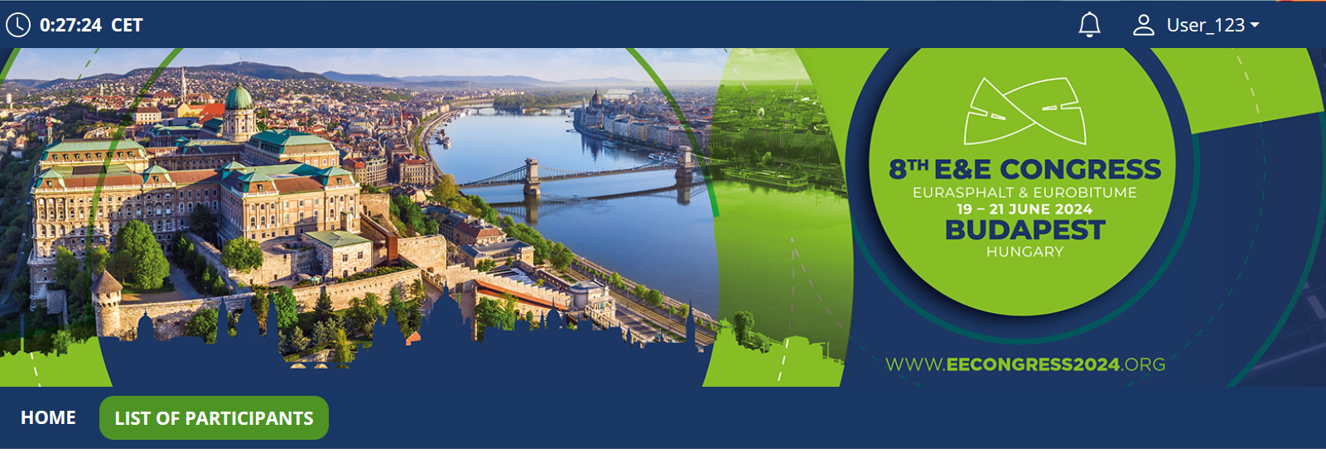
Click on your name, again in the right upper corner

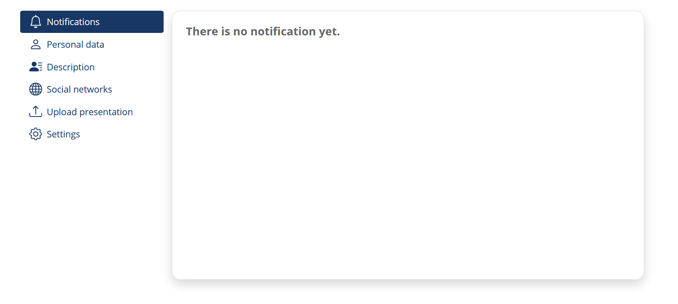
There please select option either Upload presentation or Poster

Please do not hesitate to contact us if you have any question about the process.

Kind regards,

E&E Congress Secretariat

